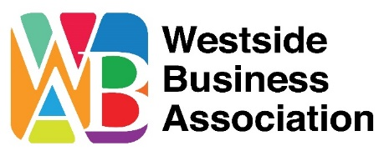

SPONSORSHIP LEVELS
Diez y Seis de Septiembre Fiesta & Mercado
Friday, September 16, 2022
$10,000 Title Sponsor
Reserved table (x2) for 8 with premium seating
Catered dinner for you/guests and 2 drink tickets per person
Stage named after Title Sponsor
Banner prominently displayed on mainstage
Company name on table
Special recognition of Company, name & logo on sponsor board/program
Special recognition of Company, name & logo on all pre-event advertising
MC mention throughout the event (10 promos)

$5,000 “Independencia” Sponsor
Reserved table (x2) for 8 with premium seating
Catered dinner for you/guests and 2 drink tickets per person
Banner displayed in the Plaza during event
Company name on table
Special recognition of Company, name & Logo on sponsor board/program
Special recognition of Company, name & Logo on all pre-event advertising
MC mention throughout the event (5 promos)

$1,500 “Grito de Delores” Sponsor
Reserved table for 8
Catered dinner for you/guests and 2 drink tickets per person
Banner displayed on premises during event
Company name on table
Recognition of Company name on sponsor board
Company name on all pre-event advertising

$500 “Padre Hidalgo” Sponsor
Reserved table for 8
Catered dinner for you/guests and 1 drink tickets per person
Banner displayed on premises during event
Company name mentioned on sponsor board
Company name on all pre-event advertising

WBA is a 501(3) (c) Non-profit organization.
Partial proceeds from this event to
benefit the Antonio E Garcia After School & Summer Children’s Programs

